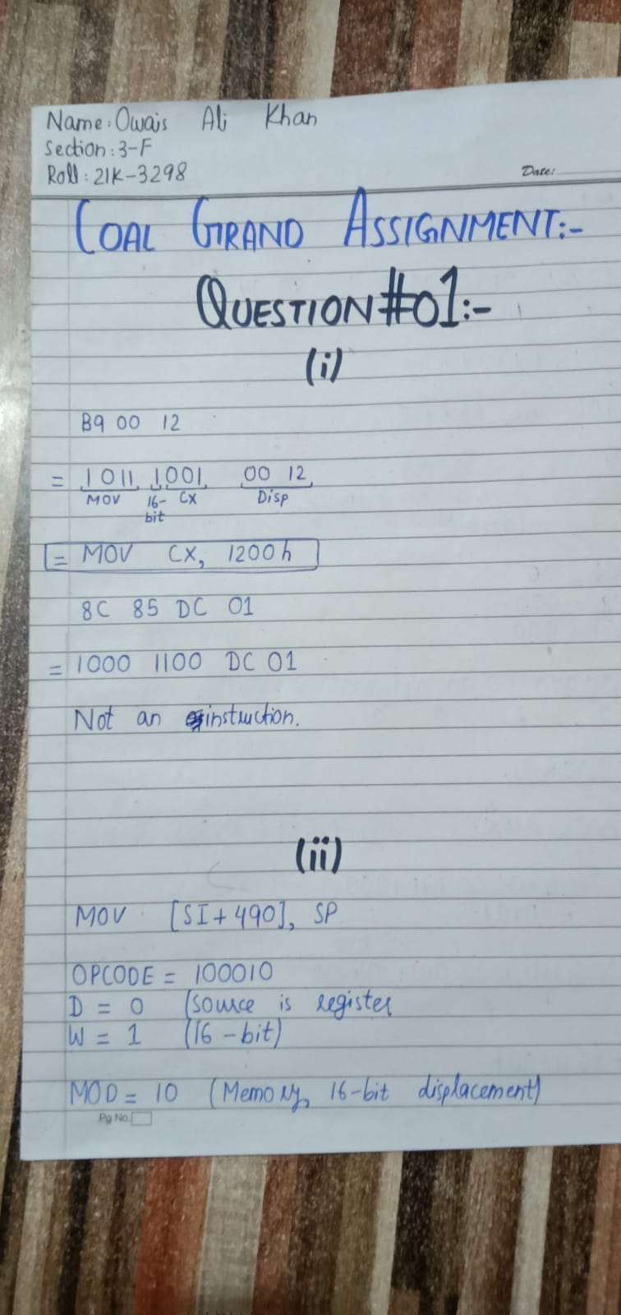

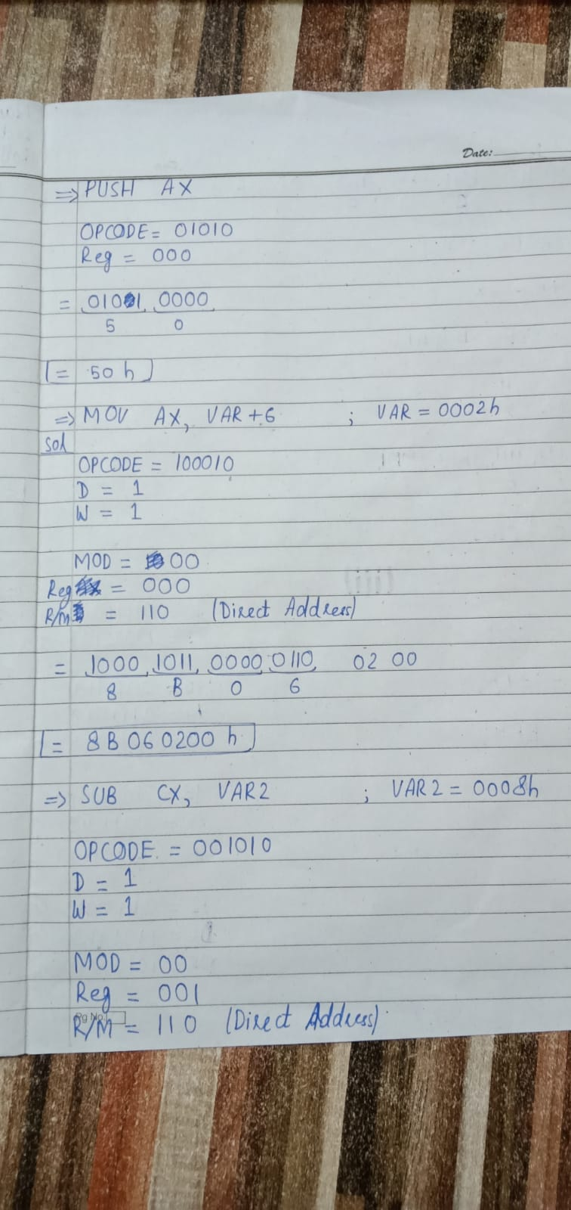

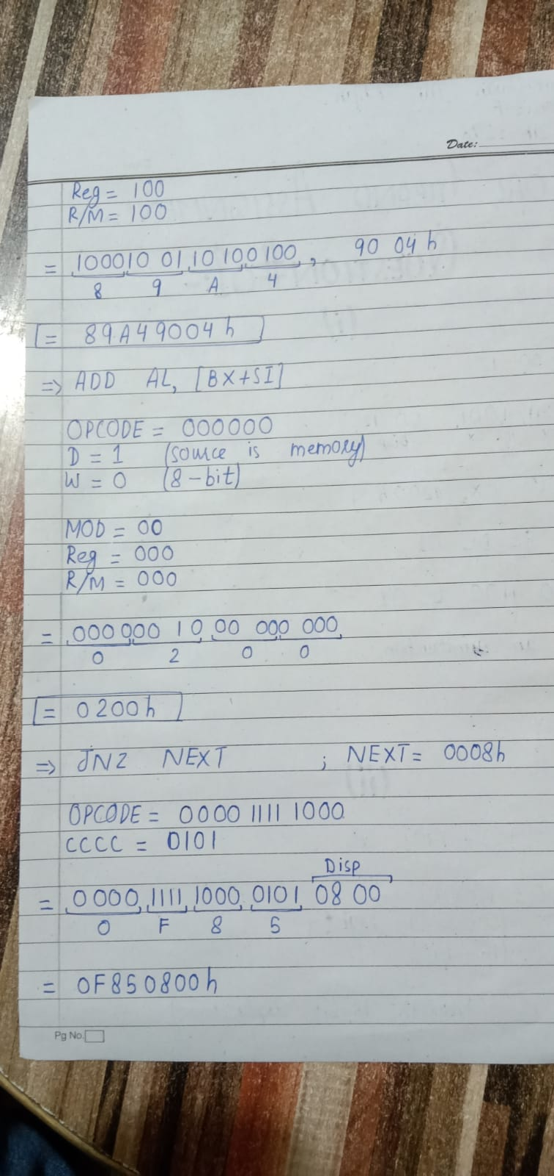

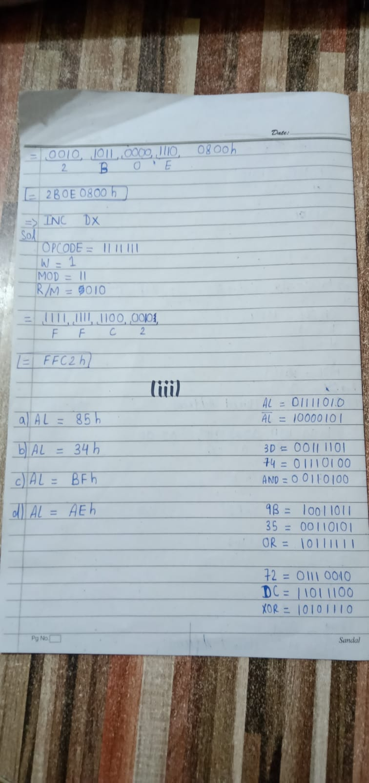

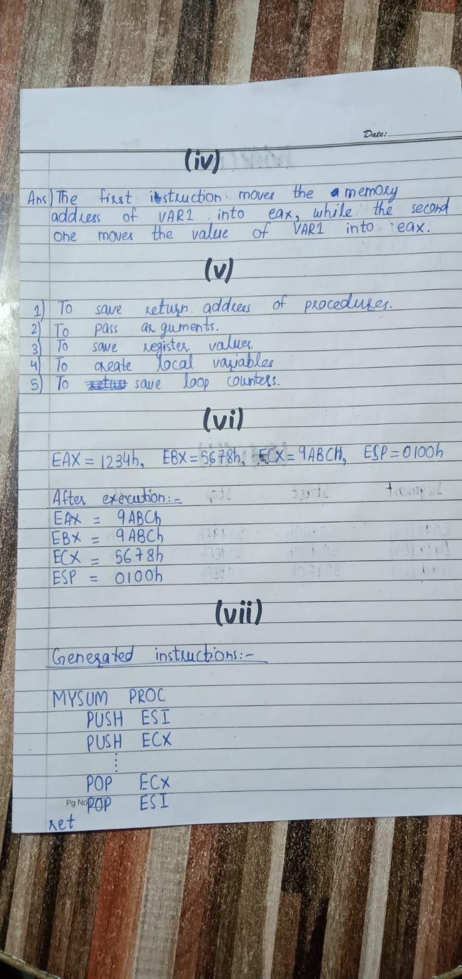

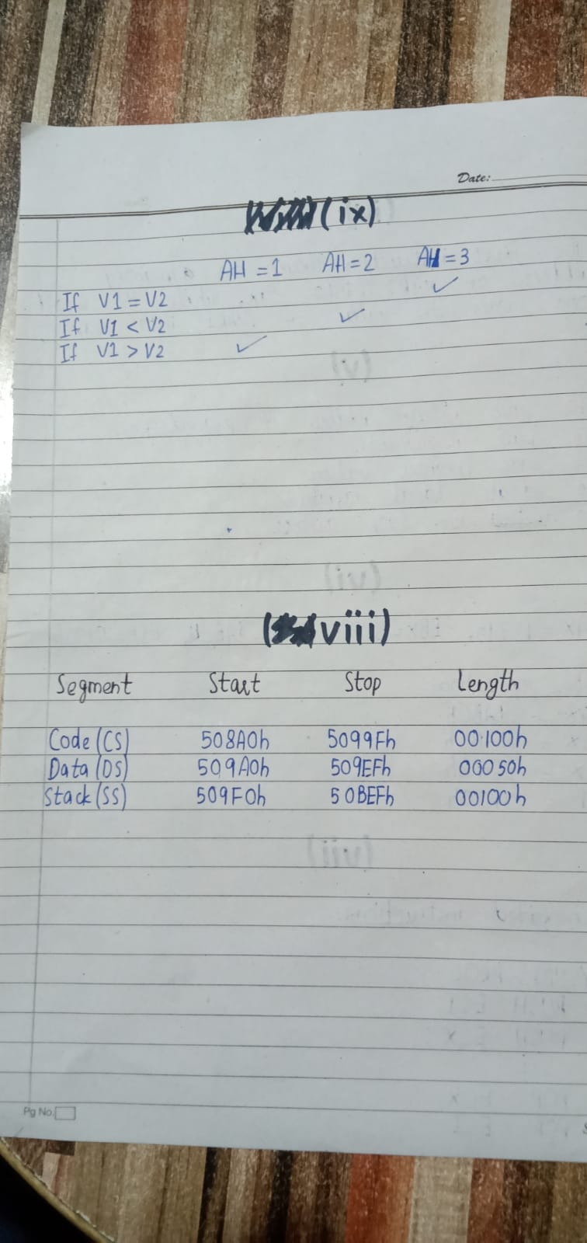

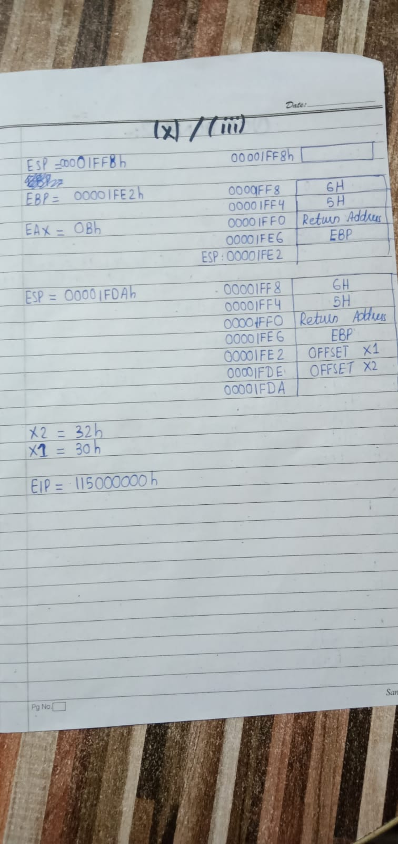

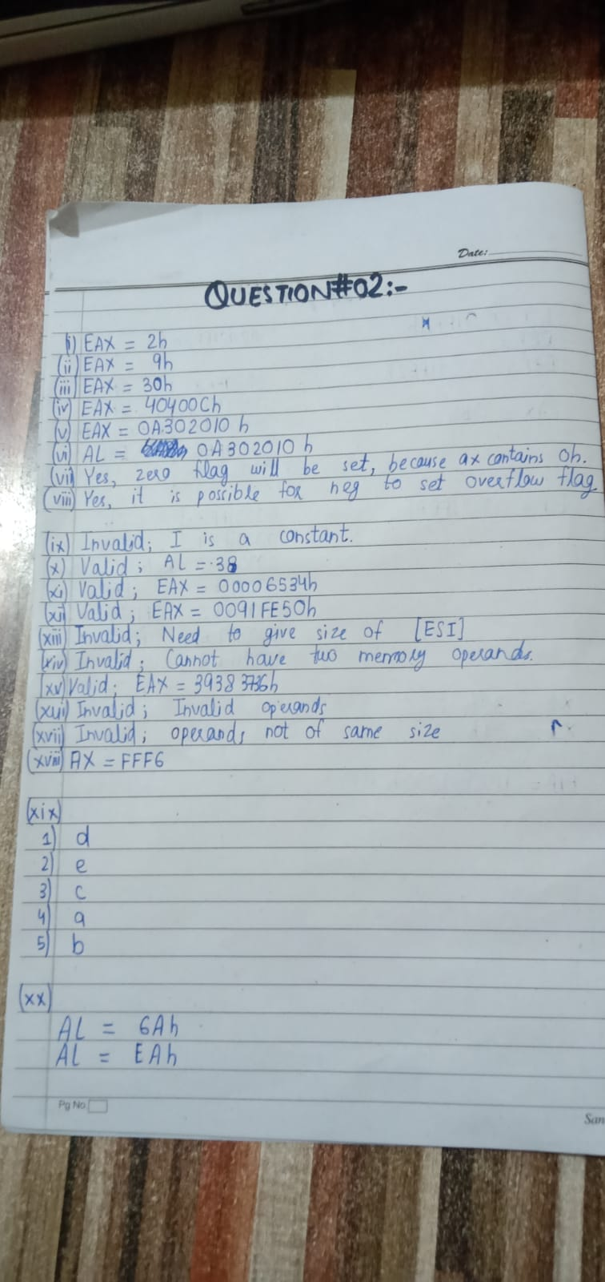

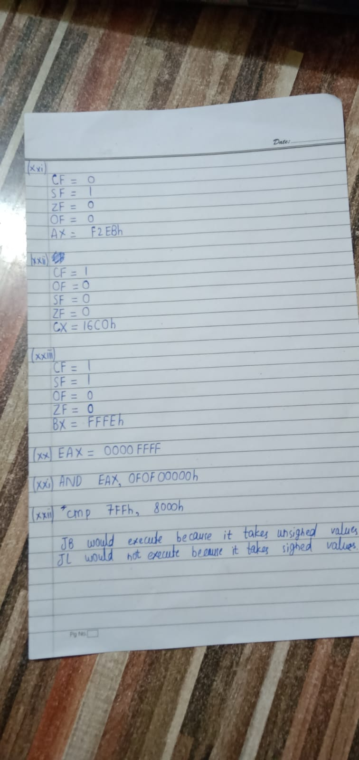

Question # 03(i):

TITLE QUESTION 3(i)

INCLUDE Irvine32.inc

INCLUDE Macros.inc

.data

OP1 SDWORD ?

OP2 SDWORD ?

OP3 SDWORD ?

X DWORD 0

Y DWORD 0

VAL1 SDWORD ?

VAL2 SDWORD ?

VAL3 SDWORD ?

.code

main PROC

WHILE:

mov eax, OP1

cmp eax, OP2

jge END_WHILE

mov eax, OP3

cmp eax, OP2

jne ELSE

mov ebx, Y

add ebx, 2

mov X, ebx

ELSE:

mov ebx, Y

add ebx, 10

mov X, ebx

jmp WHILE

exit

main ENDP

main PROC

mov eax, VAL1

mov ebx, VAL2

mov ecx, VAL3

cmp eax, ebx

jle ENDD

cmp ebx, ecx

jle ENDD

mov x, 10

ENDD:

mov x, 20

exit

main ENDP

END main

Question # 03(ii):

TITLE QUESTION 3(ii)

INCLUDE Irvine32.inc

INCLUDE Macros.inc

.data

X DWORD 21

Y DWORD 33

Z DWORD 61

.code

main PROC

mov eax, X

mov ebx, Y

mov ecx, Z

call MINIMUM

mWrite "Minimum value is: "

call WriteDec

call Crlf

exit

main ENDP

MINIMUM PROC ; takes arguments in eax, ebx and ecx. Returns minimum value in eax.

cmp eax, ebx

jle NEXT

mov eax, ebx

NEXT:

cmp eax, ecx

jle ENDD

mov eax, ecx

ENDD:

ret

MINIMUM ENDP

END main

Question # 03(iii):

TITLE QUESTION 3(iii)

INCLUDE Irvine32.inc

INCLUDE Macros.inc

.data

Table1 BYTE 100 DUP(?)

Table2 BYTE 100 DUP(?)

Constant DWORD ?

.code

main PROC

call Copy

push Constant

push OFFSET Table1

push LENGTHOF Table1

call Search

exit

main ENDP

Copy PROC

cld

mov esi, OFFSET Table1

mov edi, OFFSET Table2

mov ecx, LENGTHOF Table1

rep MOVSB

ret

Copy ENDP

Search PROC

MOV ecx, [esp + 4] ; Length

MOV esi, [esp + 8] ; Offset

MOV eax, [esp + 12] ; Value

MOV edi, -1

L1:

INC edi

CMP al, [esi + edi]

LOOPNZ L1

JZ L2

INC edi

L2:

ret 12

Search ENDP

END main

Question # 03(iv-a):

TITLE QUESTION 3(iv)

INCLUDE Irvine32.inc

INCLUDE Macros.inc

.data

n DWORD 5

k DWORD 2

.code

main PROC

mWrite "Enter value of n: "

call ReadDec

mov n, eax

mWrite "Enter value of k: "

call ReadDec

mov k, eax

call Crlf

push k

push n

call Binomial

mWrite "Binomial coefficient is: "

call WriteDec

call Crlf

exit

main ENDP

Binomial PROC

push ebp

mov ebp, esp

push ebx

sub esp, 8

mov eax, [ebp+12]

cmp eax, [ebp+8]

jle L2

mov eax, 0

jmp L3

L2:

cmp [ebp+12], 0

je L4

mov eax, [ebp+12]

cmp eax, [ebp+8]

jne L5

L4:

mov eax, 1

jmp L3

L5:

mov edx, [ebp+12]

sub edx, 1

mov eax, [ebp+8]

sub eax, 1

mov [esp+4], edx

mov [esp], eax

call Binomial

mov ebx, eax

mov edx, [ebp+8]

sub edx, 1

mov eax, DWORD PTR [ebp+12]

mov DWORD PTR [esp+4], eax

mov DWORD PTR [esp], edx

call Binomial

add eax, ebx

L3:

add esp, 8

pop ebx

pop ebp

ret

Binomial ENDP

END main

Question # 03(iv-b):

TITLE QUESTION 3(iv.b)

INCLUDE Irvine32.inc

INCLUDE Macros.inc

.data

x DWORD 2

n DWORD 4

.code

main PROC

mWrite "Enter value of x: "

call ReadDec

mov x, eax

mWrite "Enter value of n: "

call ReadDec

mov n, eax

call Crlf

push n

push x

call Power

mWrite "Nth power of x is: "

call WriteDec

call Crlf

exit

main ENDP

Power PROC

push ebp

mov ebp, esp

sub esp, 8

mov eax, [ebp + 12]

cmp eax, 0

jne L1

mov eax, 1

jmp ENDD

L1:

mov edx, [ebp + 12]

sub edx, 1

mov eax, [ebp + 8]

mov [esp + 4], edx

mov [esp], eax

call Power

mov edx, 0

mul DWORD PTR [esp]

ENDD:

add esp, 8

pop ebp

ret

Power ENDP

END main

Question # 03(v):

TITLE QUESTION 3(v)

INCLUDE Irvine32.inc

INCLUDE Macros.inc

.data

n DWORD 1

.code

main PROC

mWrite "Enter value of n: "

call ReadDec

mov n, eax

call Crlf

push n

call Fibonacci

mWrite "Nth term of Fibonacci sequence is: "

call WriteDec

call Crlf

exit

main ENDP

Fibonacci PROC

push ebp

mov ebp, esp

push ebx

sub esp, 4

mov eax, [ebp + 8]

cmp eax, 0

jne NEXT

mov eax, 0

jmp ENDD

NEXT:

cmp eax, 1

jne L1

mov eax, 1

jmp ENDD

L1:

mov eax, [ebp + 8]

sub eax, 1

mov [esp], eax

call Fibonacci

mov ebx, eax

mov eax, [ebp + 8]

sub eax, 2

mov [esp], eax

call Fibonacci

add eax, ebx

ENDD:

add esp, 4

pop ebx

pop ebp

ret

Fibonacci ENDP

END main

Question # 03(vi):

TITLE QUESTION 3(vi)

INCLUDE Irvine32.inc

INCLUDE Macros.inc

.data

intArray DWORD 60, 4, 17, 45, 7, 69, 21, 33, 96, 81

count DWORD 10

.code

main PROC

mWrite "Array values: "

mov ecx, count

mov esi, OFFSET intArray

PRINT:

mov eax, [esi]

call WriteInt

mWrite " "

add esi, 4

loop PRINT

call Crlf

call Crlf

mov ecx, count

mov esi, OFFSET intArray

call Exchange

mWrite "After Exchange Sort: "

mov ecx, count

mov esi, OFFSET intArray

PRINT2:

mov eax, [esi]

call WriteInt

mWrite " "

add esi, 4

loop PRINT2

call Crlf

exit

main ENDP

Exchange PROC

mov eax, 0

mov ebx, 0

L1:

cmp ecx, 1

JBE END_LOOP1

push ecx

lea edi, [esi+4]

L2:

cmp ecx, 1

JBE END_LOOP2

mov eax, [esi]

mov ebx, [edi]

cmp eax, ebx

JBE NotSwapped

push edi

push esi

call SWAP

pop esi

pop edi

NotSwapped:

add edi, 4

loop L2

END_LOOP2:

add esi, 4

pop ecx

loop L1

END_LOOP1:

ret

Exchange ENDP

SWAP PROC

push ebp

mov ebp, esp

mov esi, [ebp + 8]

mov edi, [ebp + 12]

mov eax, [esi]

mov ebx, [edi]

xchg eax, ebx

mov [esi], al

mov [edi], bl

mov [ebp + 8], esi

mov [ebp + 12], edi

mov esp, ebp

pop ebp

ret

SWAP ENDP

END main

Question # 03(vii):

TITLE Question 3(vii)

INCLUDE Irvine32.inc

INCLUDE Macros.inc

.data

intArray DWORD 60, 4, 17, 45, 7

count DWORD 5

.code

main PROC

mWrite "Array values: "

mov ecx, count

mov esi, OFFSET intArray

PRINT:

mov eax, [esi]

call WriteInt

mWrite " "

add esi, 4

loop PRINT

call Crlf

call Crlf

push count

push OFFSET intArray

call SelectSort

mWrite "After SelectSort: "

mov ecx, count

mov esi, OFFSET intArray

PRINT2:

mov eax, [esi]

call WriteInt

mWrite " "

add esi, 4

loop PRINT2

call Crlf

exit

main ENDP

SelectSort PROC, array:PTR DWORD, array_size:DWORD

mov esi, array

mov ecx, array_size

mov eax, 0

L1:

push ecx

push esi

mov eax, [esi]

mov edi, array

L2:

mov ebx, [edi]

cmp eax, ebx

JAE NotSwapped

mov eax, ebx

mov esi, edi

NotSwapped:

add edi, 4

loop L2

sub edi, 4

push edi

push esi

call SWAP

pop esi

pop ecx

loop L1

ret

SelectSort ENDP

SWAP PROC

push ebp

mov ebp, esp

mov esi, [ebp + 8]

mov edi, [ebp + 12]

mov eax, [esi]

mov ebx, [edi]

xchg eax, ebx

mov [esi], eax

mov [edi], ebx

mov [ebp + 8], esi

mov [ebp + 12], edi

mov esp, ebp

pop ebp

ret 8

SWAP ENDP

END main

Question # 04(i):

TITLE Question 4(i)

INCLUDE Irvine32.inc

INCLUDE Macros.inc

.data

Sequence_Number DWORD 0

Revision_Count DWORD 0

Status DWORD 0

Sensor_Data DWORD 0

.code

main PROC

mov ebx, eax

AND ebx, 0FFFh

mov Sequence_Number, ebx

mov ebx, eax

shr ebx, 12

AND ebx, 111b

mov Revision_Count, ebx

mov ebx, eax

shr ebx, 15

AND ebx, 1b

mov Status, ebx

mov ebx, eax

shr ebx, 16

AND ebx, 0FFFFh

mov Sensor_Data, ebx

mWrite "EAX: "

call WriteBin

call Crlf

mWrite "Sequence_Number: "

mov eax, Sequence_Number

call WriteBin

call Crlf

mWrite "Revision_Count: "

mov eax, Revision_Count

call WriteBin

call Crlf

mWrite "Status: "

mov eax, Status

call WriteBin

call Crlf

mWrite "Sensor_Data: "

mov eax, Sensor_Data

call WriteBin

call Crlf

exit

main ENDP

END main

Question # 04(ii):

TITLE Question 4(ii)

INCLUDE Irvine32.inc

INCLUDE Macros.inc

.data

X DWORD 0

.code

main PROC

mWrite "Enter value of X: "

call ReadInt

mov X, eax

mov ebx, X

mov ecx, X

mov edx, X

shl eax, 0

shl ebx, 1

shl ecx, 2

shl edx, 4

add eax, ebx

add eax, ecx

add eax, edx

call Crlf

mWrite "X multiplied by 23 is: "

call WriteInt

call Crlf

exit

main ENDP

END main

Question # 04(iii):



Question # 04(iv):

TITLE Question 4(iv)

INCLUDE Irvine32.inc

INCLUDE Macros.inc

.data

source BYTE "this is the source string.", 0

size_S = ($ - source)

target BYTE size_S DUP(0)

.code

main PROC

cld

mWrite "Source string: "

mov edx, OFFSET source

call WriteString

call Crlf

mov ebx, 0

mov esi, OFFSET source

mov ecx, size_S

L1:

push ecx

mov edi, OFFSET target

lodsb

mov ecx, size_S

repne scasb

jz CONTINUE

mov target[ebx], al

add ebx, 1

CONTINUE:

pop ecx

loop L1

mov target[ebx], 0

mWrite "Target string: "

mov edx, OFFSET target

call WriteString

call Crlf

exit

main ENDP

END main

Question # 04(v):

TITLE QUESTION 4(v)

INCLUDE Irvine32.inc

INCLUDE Macros.inc

.data

intArray SDWORD 60, 4, 17, 45, 7, 69, 21, 33, 96, 81

count DWORD 10

integer SDWORD ?

;SEARCH_RECURSE PROTO, array:PTR SDWORD, arrayLength:DWORD, value:SDWORD

;INVOKE SEARCH_RECURSE, ADDR intArray, count, integer

.code

main PROC

mWrite "Array values: "

mov ecx, count

mov esi, OFFSET intArray

PRINT:

mov eax, [esi]

call WriteInt

mWrite " "

add esi, 4

loop PRINT

call Crlf

call Crlf

mWrite "Enter integer value to search: "

call ReadInt

mov integer, eax

push integer

push count

push OFFSET intArray

call SEARCH_RECURSE

cmp eax, -1

je NOT_FOUND

mWrite "Given value: "

xchg eax, integer

call WriteDec

xchg eax, integer

mWrite " found at index: "

call WriteDec

call Crlf

jmp ENDD

NOT_FOUND:

mWrite "Given value not found in array."

call Crlf

ENDD:

exit

main ENDP

;SEARCH_RECURSE PROC, array:PTR SDWORD, arrayLength:DWORD, value:SDWORD

SEARCH_RECURSE PROC

push ebp

mov ebp, esp

sub esp, 12

mov ecx, [ebp + 12]

cmp ecx, 0

jle ENDD

mov esi, [ebp + 8]

mov eax, [esi]

cmp eax, [ebp + 16]

je FOUND

mov eax, -1

mov esi, [ebp + 8]

add esi, 4

mov ecx, [ebp + 12]

dec ecx

mov edx, [ebp + 16]

mov [esp + 8], edx

mov [esp + 4], ecx

mov [esp], esi

call SEARCH_RECURSE

jmp ENDD

FOUND:

mov eax, 10

sub eax, [ebp + 12]

add esp, 12

pop ebp

ret

ENDD:

add esp, 12

pop ebp

ret

SEARCH_RECURSE ENDP

END main

Question # 04(vi):

TITLE QUESTION 4(vi)

INCLUDE Irvine32.inc

INCLUDE Macros.inc

.data

MOON BYTE 20 DUP(?)

.code

main PROC

call STAR_ARRAY

mov esi, OFFSET MOON

mov ecx, 20

PRINT:

mov al, [esi]

call WriteChar

inc esi

loop PRINT

call Crlf

exit

main ENDP

STAR_ARRAY PROC

push ebp

mov ebp, esp

sub esp, 20

mov ecx, 19

L1:

cmp ecx, 0

js L2

lea edx, [ebp-20]

mov eax, ecx

add eax, edx

mov BYTE PTR [eax], 42 ; '*' = 42

mov eax, ecx

add eax, OFFSET MOON

mov BYTE PTR [eax], 120 ; 'x' = 120

sub ecx, 1

jmp L1

L2:

lea esi, [ebp-20]

mov ecx, 20

PRINT:

mov al, [esi + ecx - 1]

call WriteChar

loop PRINT

call Crlf

add esp, 20

pop ebp

ret

STAR_ARRAY ENDP

END main

Question # 04(vii):

TITLE QUESTION 4(vii)

INCLUDE Irvine32.inc

INCLUDE Macros.inc

.data

dividend_d DWORD 0D4A4h

divisor_d DWORD 0Ah

DIVIDE PROTO, dividend:DWORD, divisor:DWORD

.code

main PROC

INVOKE DIVIDE, dividend_d, divisor_d

exit

main ENDP

DIVIDE PROC, dividend:DWORD, divisor:DWORD

mov eax, dividend

mov edx, 0

mWrite "Dividend = "

call WriteHex

call Crlf

div divisor

cmp eax, 05h

jbe BASE

mov dividend, eax

INVOKE DIVIDE, dividend, divisor

BASE:

ret

DIVIDE ENDP

END main

Question # 04(viii):

TITLE QUESTION 4(viii)

INCLUDE Irvine32.inc

INCLUDE Macros.inc

.data

ArraySearchValues BYTE 20 DUP(1)

ArrayValues BYTE 1000 DUP(1)

.code

main PROC

cld

mov esi, OFFSET ArraySearchValues

mov edi, OFFSET ArrayValues

lea ecx, [1000 - 20]

L1:

push ecx

push esi

push edi

mov ecx, 20

repe cmpsb

je FOUND

pop edi

pop esi

pop ecx

add edi, 1

loop L1

mWrite "ArraySearchValues not found in ArrayValues."

call Crlf

jmp ENDD

FOUND:

mWrite "ArraySearchValues found at "

; mov eax, esi

lea eax, [esi - 20]

sub eax, OFFSET ArraySearchValues

call WriteDec

call Crlf

ENDD:

exit

main ENDP

END main

Question # 04(ix):

TITLE QUESTION 4(ix)

INCLUDE Irvine32.inc

INCLUDE Macros.inc

.data

string BYTE "SITYA", 0

source BYTE "FAST NATIONAL UNIVERSITY", 0

s_size = ($ - source) - 1

target DWORD s_size DUP(?)

.code

main PROC

mov eax, 0

mov esi, OFFSET source

mov edi, OFFSET target

mov ecx, s_size

L1:

mov al, BYTE PTR [esi]

mov DWORD PTR [edi], eax

add esi, 1

add edi, 4

loop L1

mov edi, OFFSET target

mov ecx, s_size

PRINT:

mov eax, DWORD PTR [edi]

call WriteDec

mWrite " "

add edi, 4

loop PRINT

call Crlf

call SEARCH

exit

main ENDP

SEARCH PROC

mov esi, OFFSET string

mov edi, OFFSET source

lea ecx, [s_size - 1]

L1:

INVOKE Str_compare, esi, edi

je FOUND

add edi, 1

loop L1

mWrite "Given substring: "

mov edx, OFFSET string

call WriteString

mWrite " not found in original string."

call Crlf

jmp ENDD

FOUND:

mWrite "Found substring: "

mov edx, OFFSET string

call WriteString

mWrite " in original string."

call Crlf

ENDD:

ret

SEARCH ENDP

END main